CSA1716-ARTIFICIAL INTELLIGENCE
LAB EXPERIMENTS
1. Map Coloring using CSP
Aim
To implement the Map Coloring problem using a Constraint Satisfaction Problem (CSP) in Python.
Algorithm
- Define the regions and available colors.
- Define the neighboring regions.
- Assign a color to each region.
- Check that neighboring regions do not have the same color.
- If a conflict occurs, try another color.
- Display the valid coloring.
Procedure
- Open a Python editor.
- Enter the map regions, colors, and constraints.
- Run the program.
- Observe the color assigned to each region.
Result
The Map Coloring problem is solved successfully using CSP and backtracking.
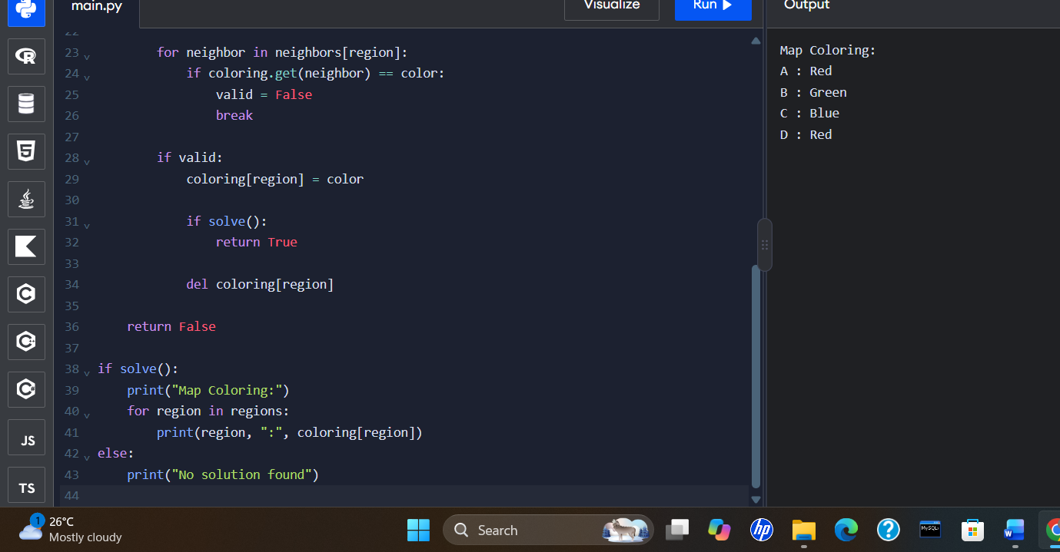
2. Tic-Tac-Toe Game
Aim
To develop a simple Tic-Tac-Toe game in Python for two players.
Algorithm
- Create a 3 × 3 board.
- Display the board.
- Ask the current player to enter a position.
- Place X or O in the selected empty position.
- Check for a winning combination or a draw.
- Repeat until the game ends.
Procedure
- Open a Python editor.
- Enter the program.
- Run the program.
- Enter positions from 1 to 9 to play the game.

Result:
The Tic-Tac-Toe game is implemented successfully for two players.
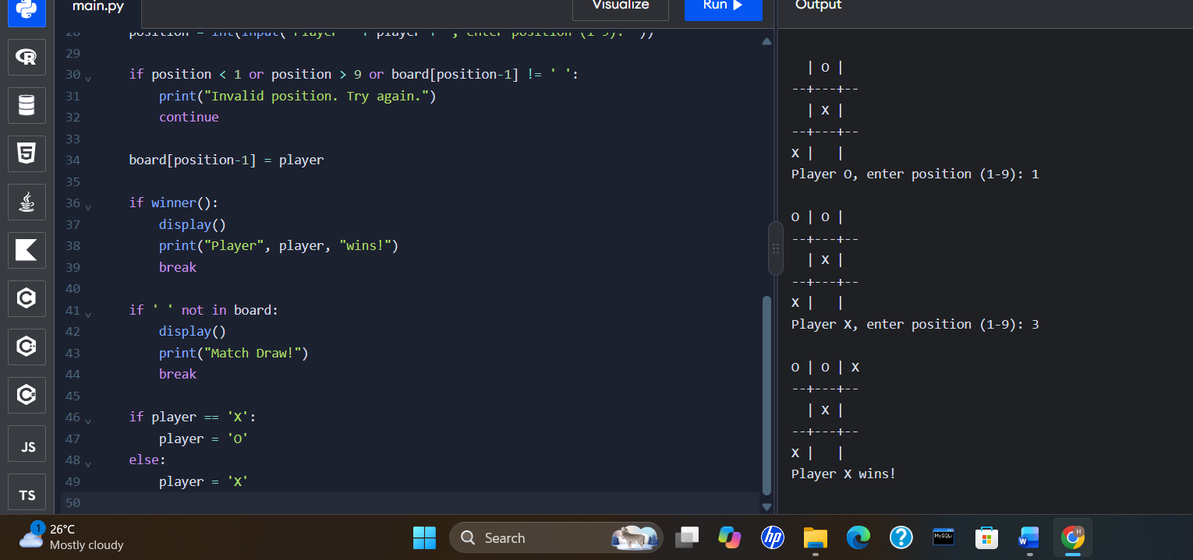
3. Minimax Algorithm for Gaming
Aim
To implement the Minimax algorithm in Python to select the best move in a game tree.
Algorithm
- Create a game tree with possible moves.
- Assign scores to the terminal nodes.
- The maximizing player selects the highest score.
- The minimizing player selects the lowest score.
- Continue until the best move is determined.
- Display the best score.
Procedure
- Open a Python editor.
- Enter the game tree and Minimax function.
- Run the program.
- Observe the best score selected by the algorithm.

Result
The Minimax algorithm is implemented successfully to find the best move in a game tree.
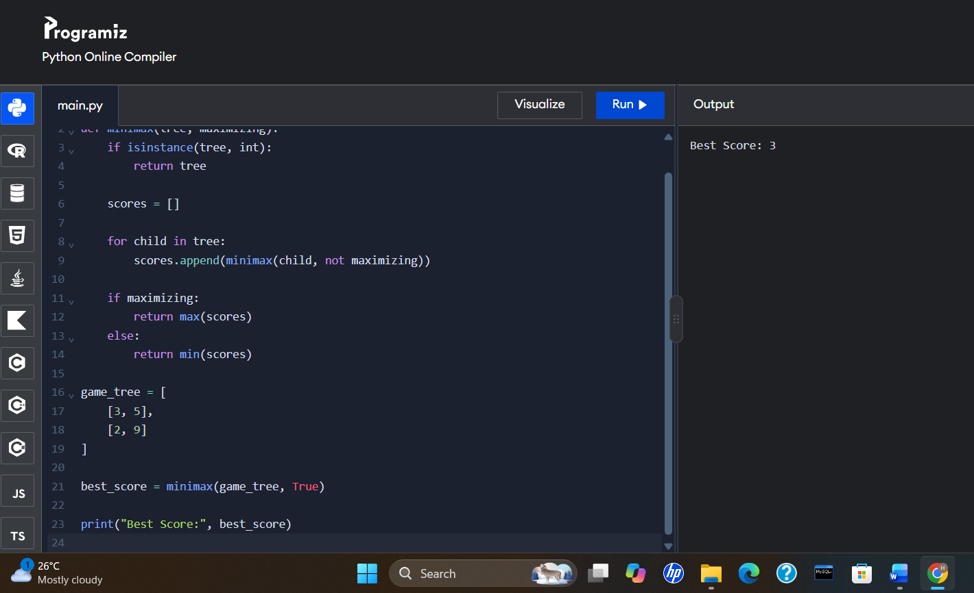
4. Alpha-Beta Pruning Algorithm for Gaming
Aim
To implement the Alpha-Beta Pruning algorithm in Python to reduce unnecessary node evaluations in a game tree.
Algorithm
- Initialize alpha to negative infinity and beta to positive infinity.
- Evaluate the game tree recursively.
- At maximizing nodes, select the highest score and update alpha.
- At minimizing nodes, select the lowest score and update beta.
- Stop exploring a branch when alpha is greater than or equal to beta.
- Display the best score.

Procedure
- Open a Python editor.
- Enter the game tree and Alpha-Beta function.
- Run the program.
- Observe the best score and the number of evaluated leaf nodes.
Result
The Alpha-Beta Pruning algorithm is implemented successfully, reducing unnecessary evaluations while finding the Minimax score.
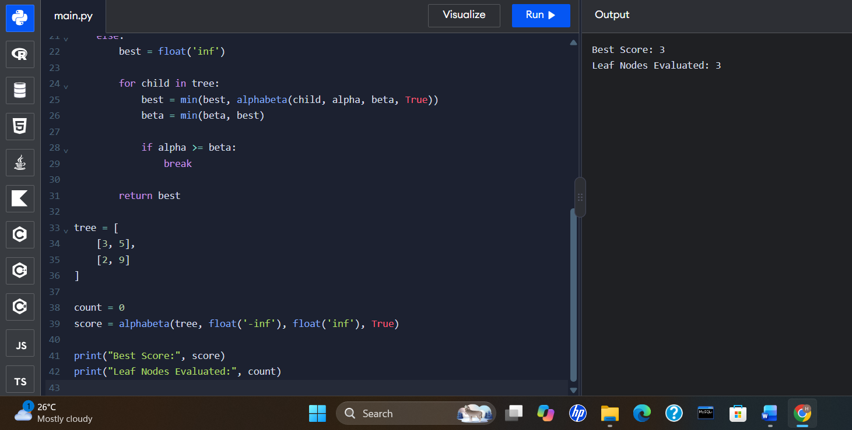

5. Decision Tree
Aim
To implement a Decision Tree classification model in Python using machine learning.
Algorithm
- Import the required libraries.
- Create a dataset containing input features and output labels.
- Train the Decision Tree classifier.
- Give a new input to the model.
- Predict and display the output class.
Procedure
- Install scikit-learn if it is not already installed using pip install scikit-learn.
- Open a Python editor.
- Enter the dataset and Decision Tree code.
- Run the program and observe the prediction.
Result
The Decision Tree model is implemented successfully to classify data.
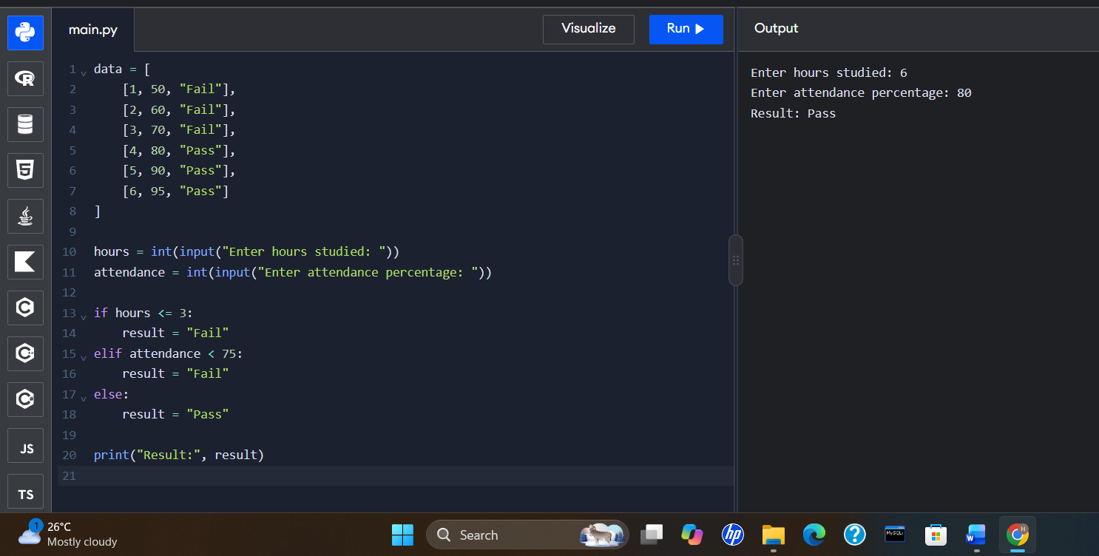

6. Feed Forward Neural Network
Aim
To implement a simple Feed Forward Neural Network in Python to produce an output using input values, weights, and the sigmoid activation function.
Algorithm
- Define the input values and weights.
- Calculate the weighted sum at the hidden layer.
- Apply the sigmoid activation function.
- Pass the hidden-layer output to the output layer.
- Apply sigmoid again and display the result.
Procedure
- Install NumPy using pip install numpy if needed.
- Open a Python editor.
- Enter the neural network program.
- Run the program and observe the output.
Result
The Feed Forward Neural Network is implemented successfully using weighted sums and the sigmoid activation function.
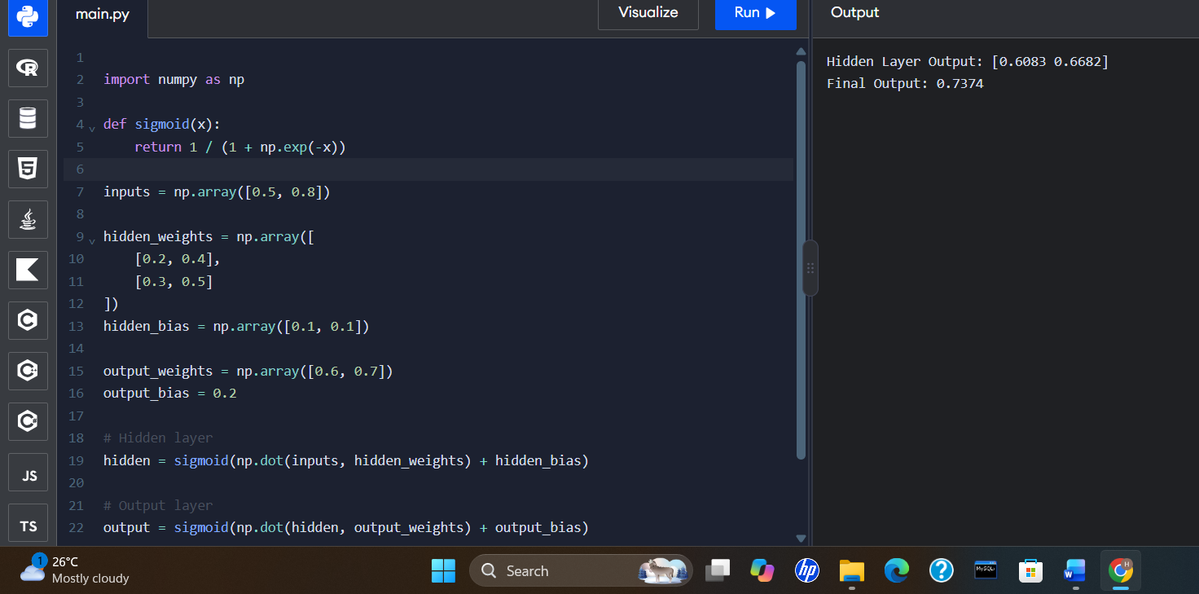

7. Prolog Program to Sum Integers from 1 to N (CO4)
Aim
To write a Prolog program to calculate the sum of integers from 1 to N.
Algorithm
- Define the base case when N is 0.
- If N is greater than 0, calculate the sum up to N − 1.
- Add N to the previous sum.
- Display the final sum.
Procedure
- Open SWI-Prolog.
- Enter the program and save it as sum.pl.
- Load the file using consult('sum.pl').
- Query the sum for a given value of N.
Result
The sum of integers from 1 to N is calculated successfully using Prolog recursion.
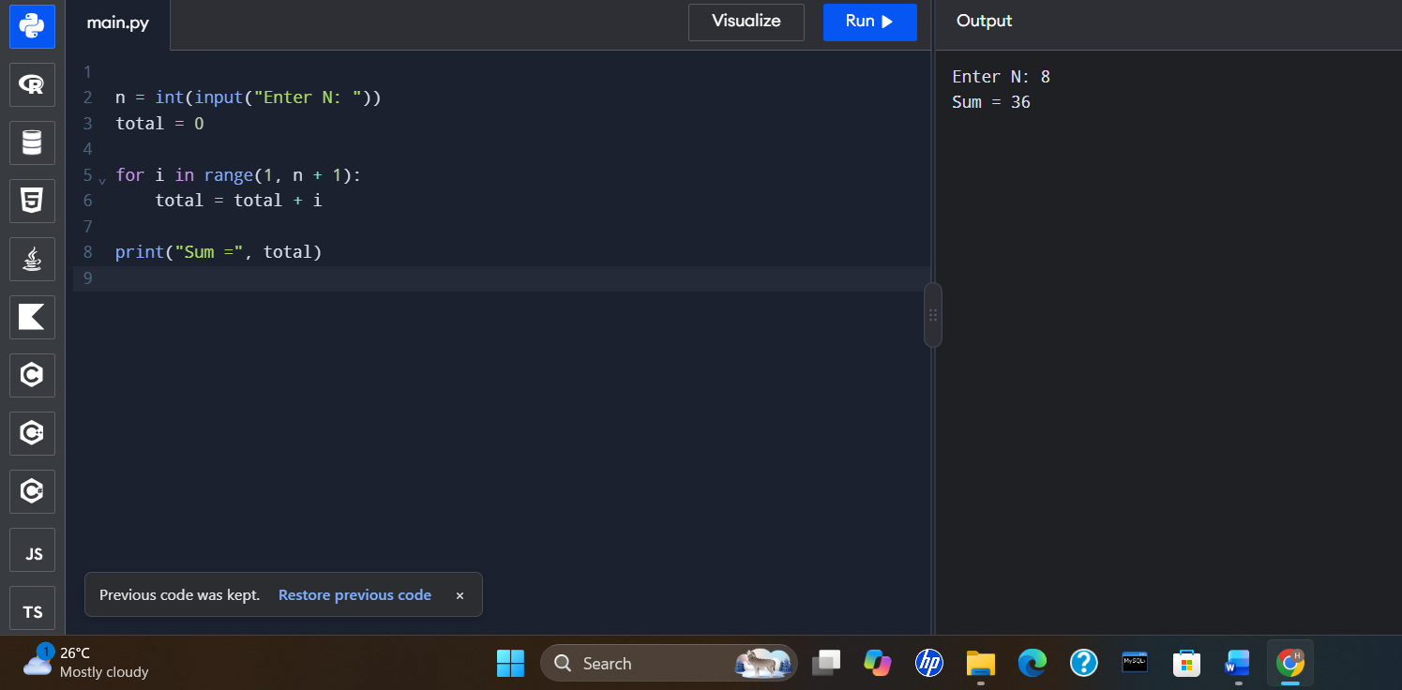

8. Prolog Database with Name and DOB
Aim
To create a database containing names and dates of birth and retrieve the details using Python.
Algorithm
- Create a database containing names and DOB.
- Get a name from the user.
- Check whether the name exists in the database.
- Display the corresponding date of birth.
- Display a message if the name is not found.
Procedure
- Open an online Python compiler.
- Copy and paste the program.
- Enter a person's name.
- Run the program and observe the output.
Result
The name and DOB database is implemented successfully using Python.
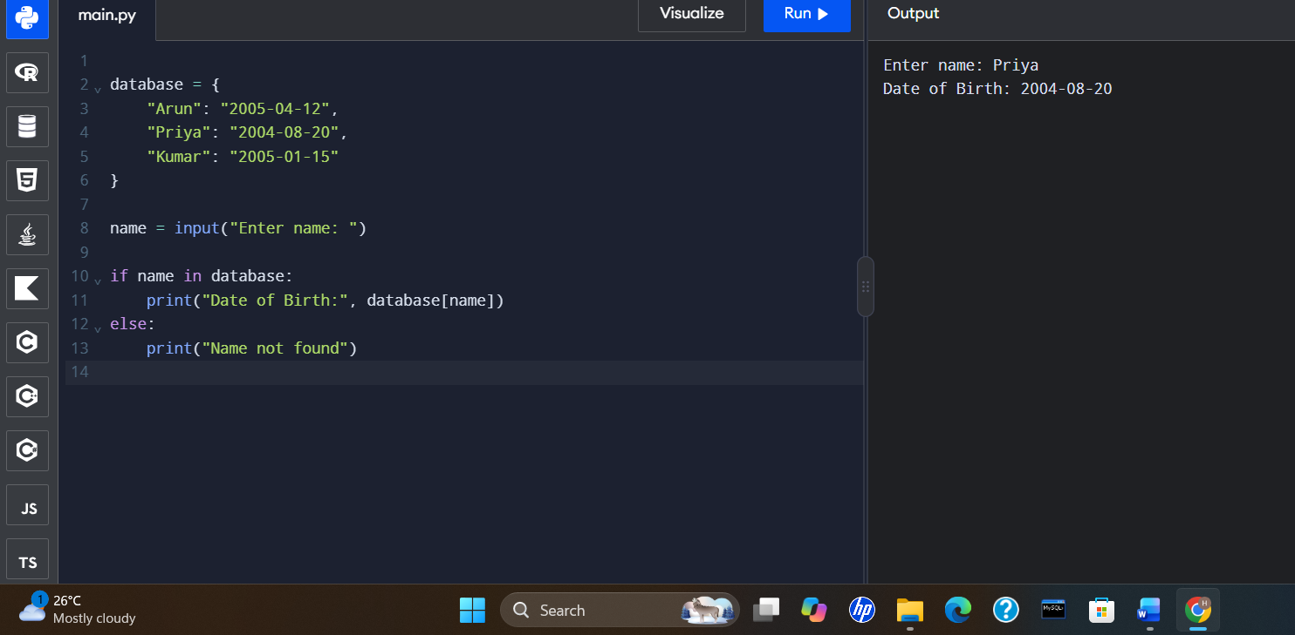
9. Student–Teacher–Subject Code Database
Aim
To create a database containing student names, teacher names, and subject codes and retrieve the details using Python.
Algorithm
- Create a database containing student, teacher, and subject-code details.
- Get a student name from the user.
- Search for the student in the database.
- Display the corresponding teacher name and subject code.
- Display a message if the student is not found.
Procedure
- Open an online Python compiler.
- Copy and paste the program.
- Enter a student name.
- Run the program and observe the output.
Result
The Student–Teacher–Subject Code database is implemented successfully using Python. 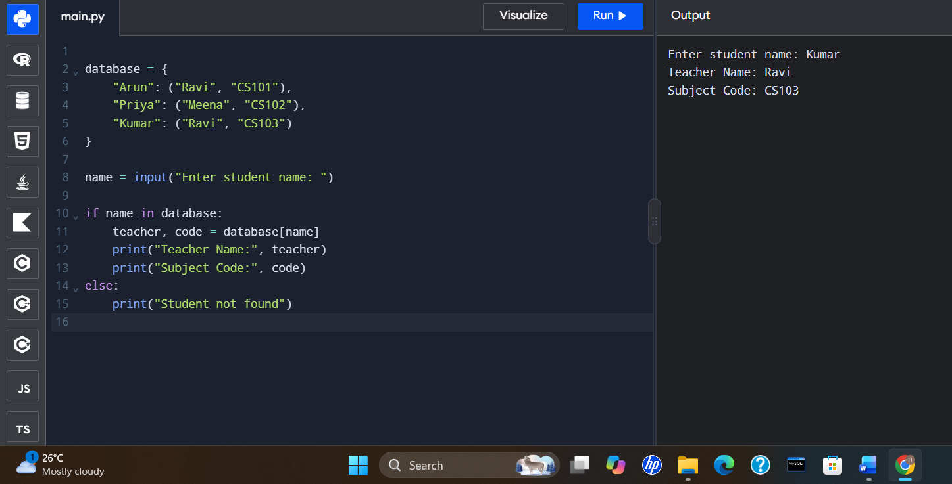

10. Planets Database
Aim
To create a database containing planet names, types, and number of moons and retrieve planet details using Python.
Algorithm
- Create a database containing planet details.
- Get a planet name from the user.
- Search for the planet in the database.
- Display its type and number of moons.
- Display a message if the planet is not found.
Procedure
- Open an online Python compiler.
- Copy and paste the program.
- Enter a planet name in lowercase.
- Run the program and observe the output.
Result
The Planets database is implemented successfully using Python.
